How to Create Web Server in Websphere Application server

Step 1: Login to IBM WAS Console.
Screenshot 1:
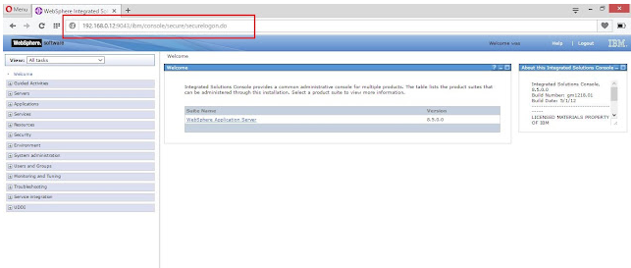
Step 2: go to the web server.
Screenshot 2:

Step 3: Click on New.
Screenshot 3:

Step 4: Provide details and click Next,
ServerName: New_webserverr
Type:IBM HTTP Server
Hostname: 192.168.0.12
Platform: Windows
Screenshot :4

Step 5: Select IHS and click Next.
Screenshot :5

Step 6: Provide details and click Next,
Port :80
Web Server Location:
Service Name:
plug-in location:
Application Mapping: All
Admin server Port:8008 (default)
Username:
Password:
Confirm Password:
Screenshot :6

Screenshot :7

Step 7: Click on Finish.
Screenshot :8

Step 8: Click on review and Save.
Screenshot :9

Screenshot :10

Step 9: Now we have created New Web Server and Status is Stopped.
Screenshot :11

Step 10: Start The IHS from services --
Screenshot :12

Step 11: Refresh the status from Console , its Started
Screenshot :13

How to generate and propagate Plug-ins from Console.

